

Changing Lives Through learning

**Student Name-Ritika Sharma**

**REPORT START**

# Client Details

I make a website on tourist agency in which I offer different clients to come and visit the website and plan for travelling.

|  |  |
| --- | --- |
| Website Name | Tourist Agency |
| Address | 16b Phillip’s street |
| Phone Number | 0224960903 |
| Email Address | ritikasharma9112000@gmail.com |
| website creator | Ritika Sharma |

# Project scope

## Purpose

The main motive of the website is to help customers to access easily the website and make their travelling easy and cheap. This website is very simple and attractive. People can follow it easily. This website can be used with all browsers like opera browser, safari, Google chrome, internet explorer, Firefox.

## Goals

* Attracts customers

This website has lot of knowledge about travelling with good options of cities and attractive packages. It looks very beautiful and help to improve the interest of costumer.

* Knowledge of Booking

This assignment gives the knowledge about different places, attractions and good packages.

## Features

* Online booking

People can book their travelling places online of by the adding their details on the booking page.

* Information about location

People can search the location of hotels, attractions places easily while your bookings of the website.

* Customers details

The website also gives the information to the customer like their phone number, Address, e-mail id.

## Target audience

* Women age group 18-40
* Men age group 18-40

# Visual Planning

1. Home page

This given website Tourist agency.co.nz is the best website about different attractive places where people can visit with their families. This website has no negative space.it also gives the information of the NEW ZEALAND like location of attractions, best rides and prices. The colour schema of this website is enhancing the beauty of the website.

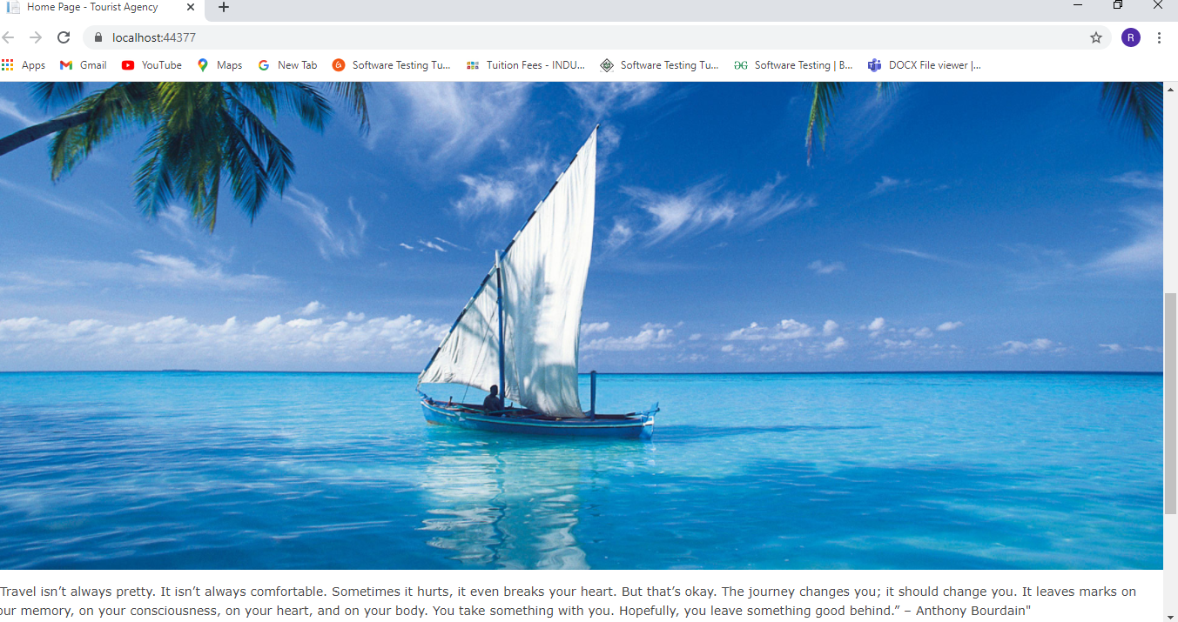

1. Activities

This is the activity page of website. This is the second page of the website. This website provides the information about variable activities which people can do in different attraction places. This page displays the delete, detail, edit and create button from where customers fill their data. some design principles also like unity, the font used in the website is increases the attraction of the customers as emphasis view point.

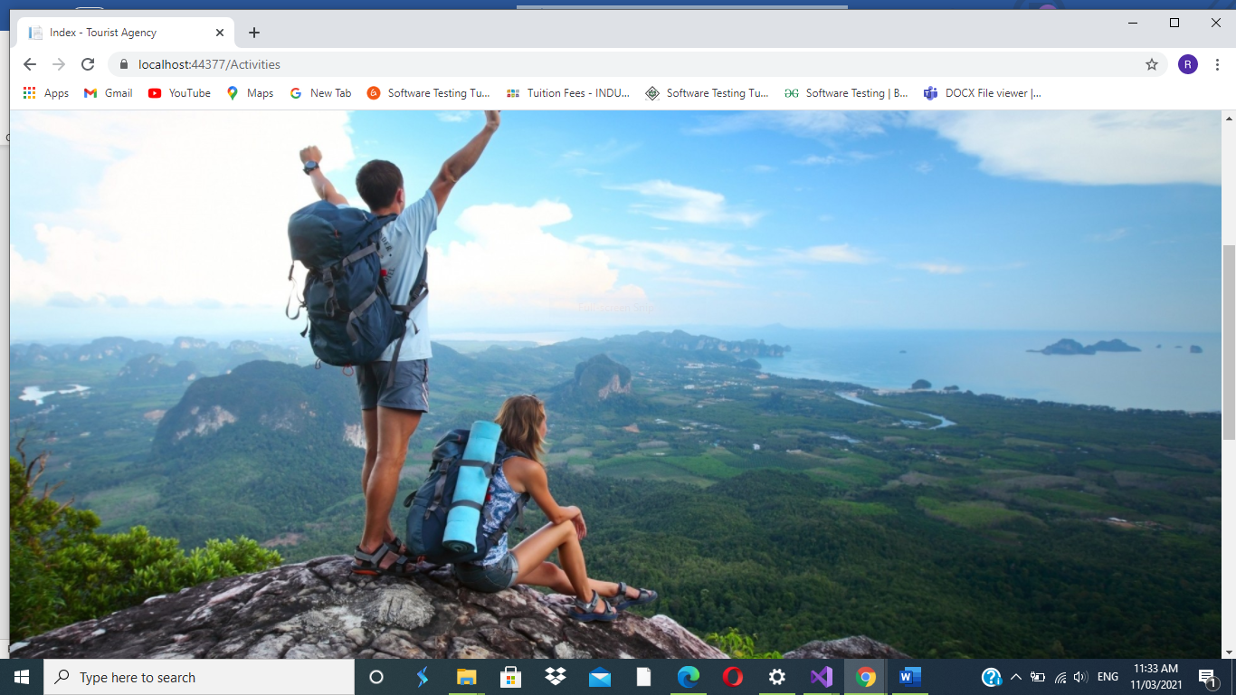

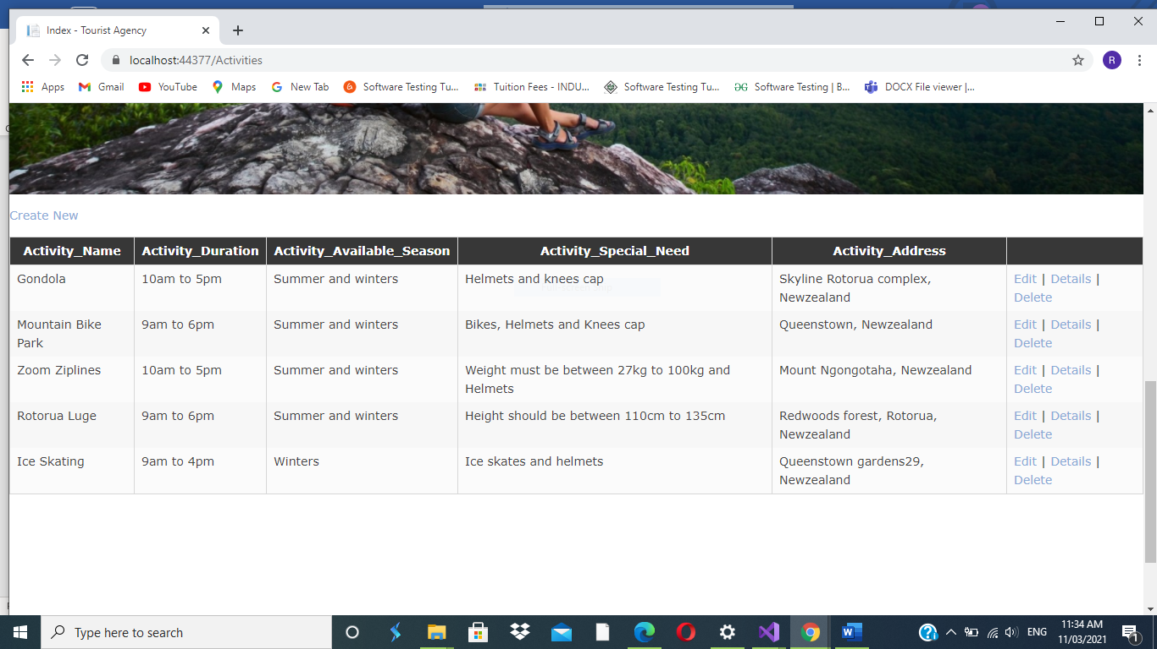

1. Agencies

This is the third page of website which is named as Agencies. This page includes the information all about different agencies in different places. The page explains briefly like how people book their travelling from different agencies.

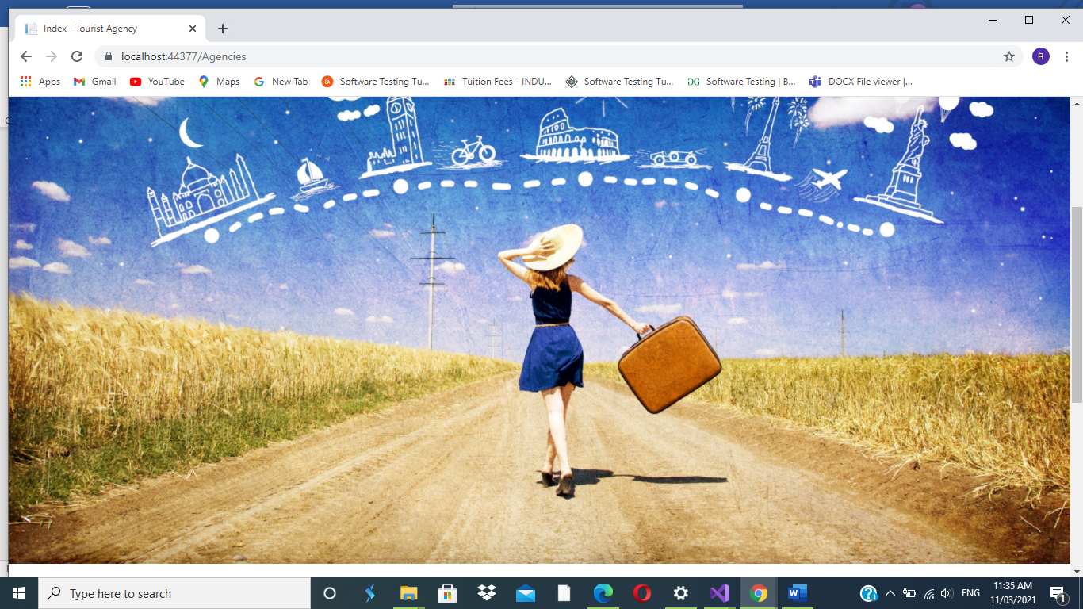

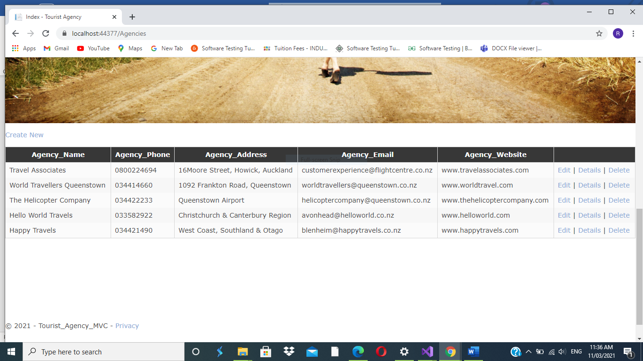

1. Bookings

The fourth page of website is Bookings. This page includes the information of booking details like how people book their packages and book various activities from this page. It will be interesting part because people easily access every pages of this website.

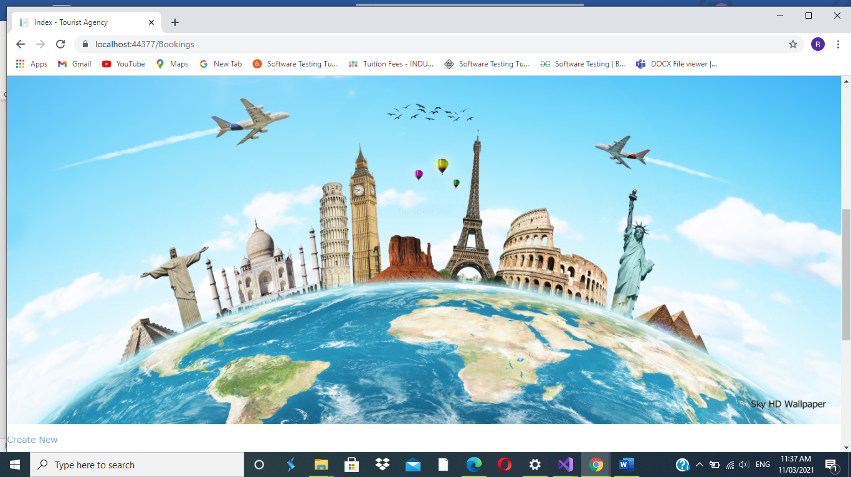

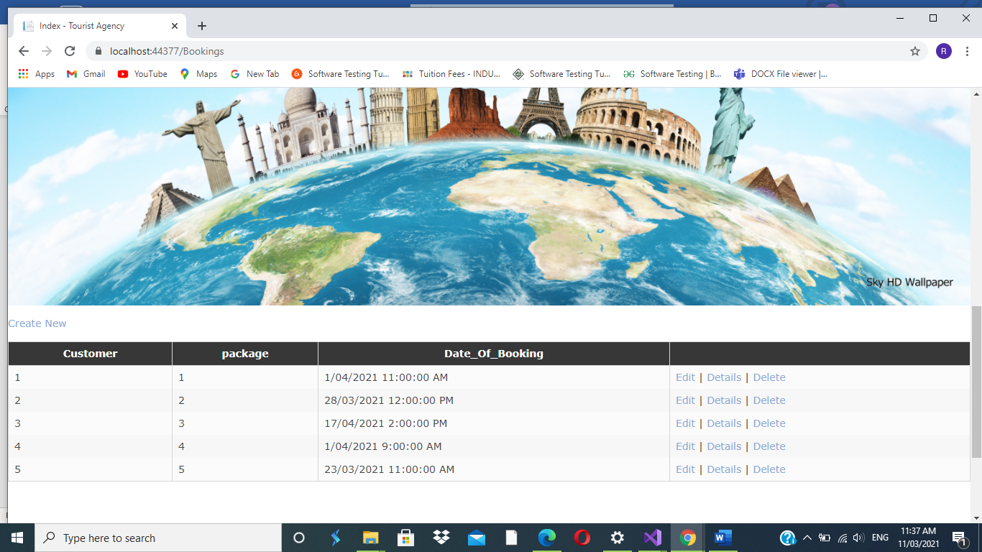

1. Customers

The fifth page is all about Customers. This page includes the information of the customers in which people add, delete or edit their information very easily.

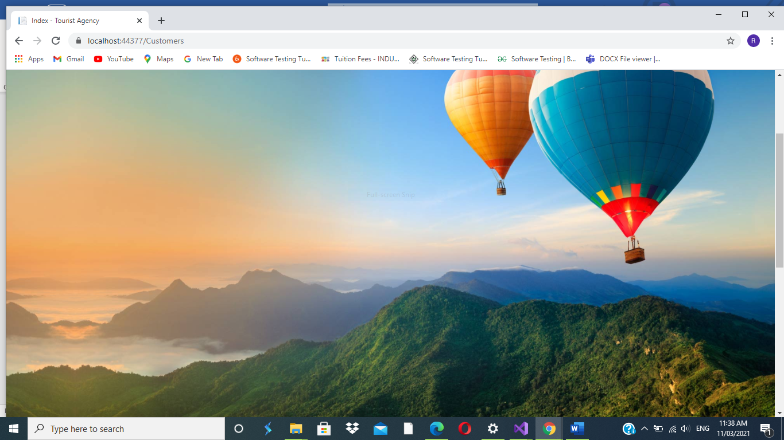

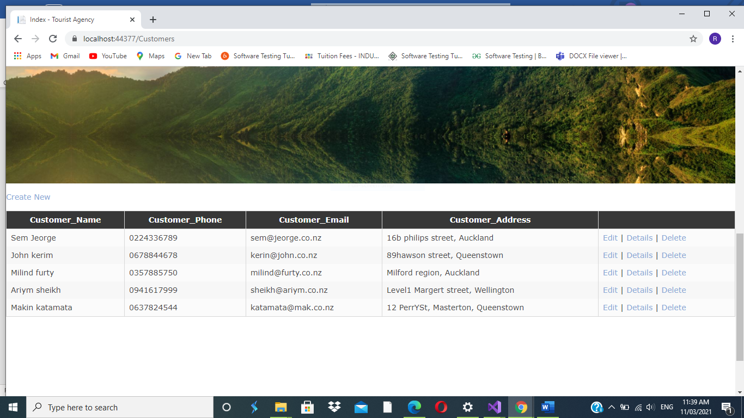

1. Packages

The last page of this website is packages. It shows the attractive packages for the customers who enjoy their summers and winters with joy and happiness.

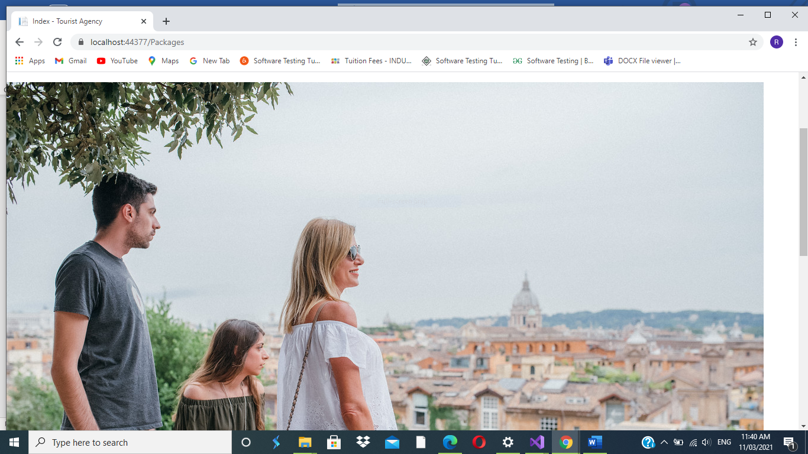

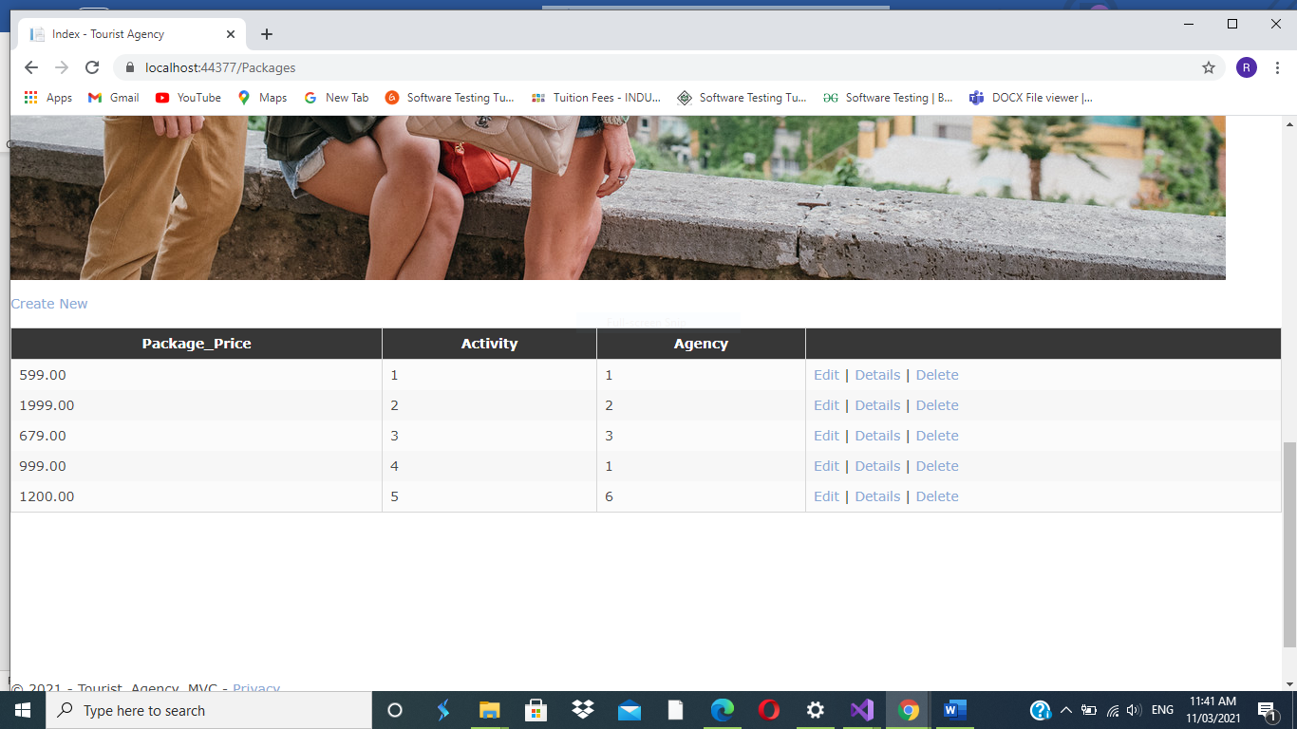

1. Register and login.

This website also includes register and login page where people can register or login their information easily.

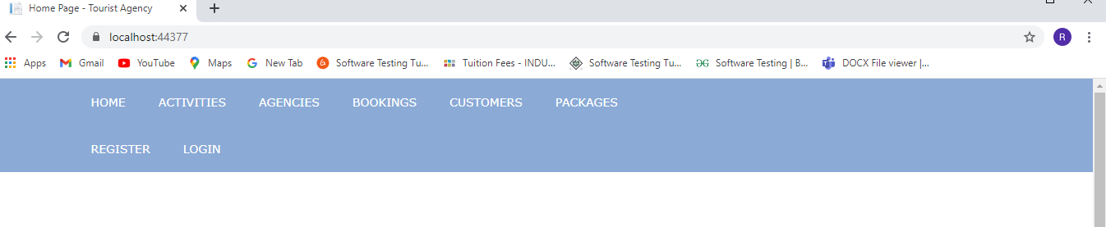

## Appearance / Style

### Colour schema

|  |  |  |  |
| --- | --- | --- | --- |
| Colour | Colour name | Colour code |  |
|  | Sky blue | #2222 |  |
|  | Pink | #3412 |  |
|  | white | #8876 |  |

### Fonts

|  |  |  |
| --- | --- | --- |
| Font style | Font family | Used for |
| Calibri light (Headings) | Sans serif | Headings |
| Calibri (Body) | Sans serif | Information |
|  |  |  |

### Logo or Brand Name



Based on the name of New Zealand.

# Tasks Detail

Here you need to provide the Gantt chart with all tasks, estimate time for each task and total time estimation.

|  |  |  |
| --- | --- | --- |
| Weeks | Tasks | Time |
| 1 | Client details  Purpose  Goals  Features  Target audience | 50 minutes  15 minutes  15 minutes  15minutes  20 minutes |
| 2 | Appearance and style  Page contact details  Domain names  Web hosting details | 50 minutes  140 minutes  20 minutes  20 minutes |
| 3 | Testing  Grammar, spellings, links | 150 minutes |
|  | Total timing | 12 hr |

# Browser Support

The website is user friendly website which can be search on any browser like safari, Opera, Google chrome, Firefox, internet explorer and so on.

|  |  |  |
| --- | --- | --- |
| Number | Browser Name | Brower Version that supports website |
| 1 | Safari | 5.1.7[11] (may9,2012) |
| 2 | Opera | 64 (2019) |
| 3 | Google chrome | 77.03865.120 |
| 4 | Firefox | 68.0.1 |
| 5 | Internet explorer | 11.0.155(8oct2019,6 days ago) [23] |

# Domain Names

The website used for NEW ZEALAND has some domain names which customer can use to open the website.

|  |  |
| --- | --- |
| No. | Domain names |
| 1 | www.new zealand.co.nz |
| 2 | www.nz group.co.nz |
| 3 | <https://nz,co.nz> |

# Web Hosting Companies Detail

The website used for the NEW ZEALAND has different hosting web companies like Host Papa, Blue host, register.com.

|  |  |  |
| --- | --- | --- |
| Number | Web Hosting Company Name | Price |
| 1 | Host Papa | Starting at $ 3.95 per month |
| 2 | Blue host | Starting at $ 4.18 per month |
| 3 | Register.com | Starting at $ 5.95 per month |

**REPORT ENDS!**